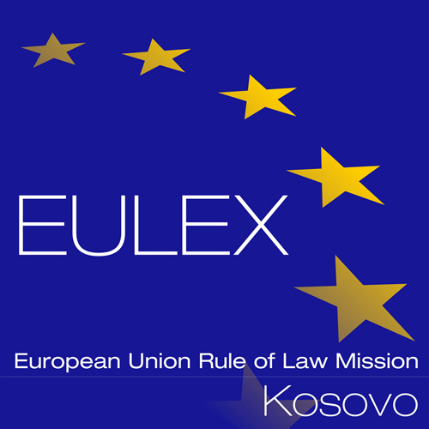

European Union Rule of Law Mission in Kosovo
EULEX Kosovo
Ndertesa Farmed
“Muharrem Fejza” p.n.
Lagja e Spitalit
10 000 Pristina, Kosovo
http://www.eulex-kosovo.eu

CLARIFICATIONS (1)

PUBLICATION REFERENCE: PROC/532/15/ Framework Contract for the Supply of Drinking Water No. 5
(EuropeAid/136777/ID/SUP/XK) Questions regarding Tender Dossier

No | Question | Answer
1 | I ask if companies based in Europe but not registered in a member country of the European Community are entitled to submit an offer ? | Participation based on the Tender Dossier - Article 3, and Contract Notice paragraph 8, as below:  Participation  3.1 “Participation is open to all natural persons who are nationals of and legal persons participating either individually or in a grouping (consortium) of tenderers which are effectively established in a the Member State of the European Union, in an official candidate country or a or a country that is a beneficiary of the Instrument for Pre-Accession Assistance, in a Member State of the European Economic Area, a country of the Western Balkans region or a contributing third State, as authorized by Council Joint Action 2008/124/CFSP of 04 February 2008 on EULEX KOSOVO as amended by JA 2009/445/CFSP and Council Decision 2010/322/CFSP, Council Decision 2012/291/CFSP, Council Decision 2013/241/CFSP, Council Decision 2014/349/CFSP and Council Decision 2014/685/CFSP of 29 September 2014. Participation is also open to international organisations. Participation of natural persons is directly governed by the specific instruments applicable to the programme under which the contract is financed.  3.2 These terms refer to all nationals of the above states and to all legal entities, companies or partnerships established in the above states. For the purposes of proving compliance with this rule, tenderers being legal persons, must present the documents required under that country’s law. In case of doubt, the Contracting Authority may ask the tenderer to provide evidence demonstrating actual compliance with the "establishment" criteria. For this purpose, legal person have to demonstrate that their legal person is formed under the law of an eligible State and that its real seat is within an eligible State. "Real seat" must be understood as the place where its managing board and its central administration are located or its principal place of business”.

