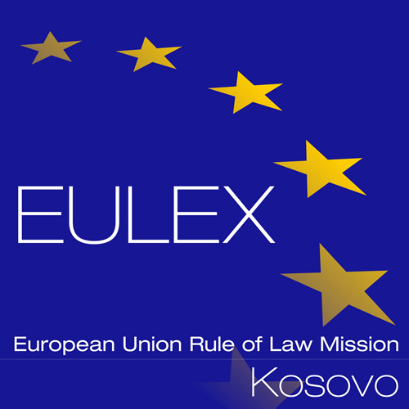

European Union Rule of Law Mission in Kosovo
EULEX Kosovo
Ndertesa Farmed
“Muharrem Fejza” p.n.
Lagja e Spitalit
10000 Pristina, Kosovo
www.eulex-kosovo.eu

CORRIGENDUM NUMBER 1

TO THE TENDER DOSSIER

PUBLICATION REFERENCE: PROC/737/17/ Renewal of Microsoft Software Assurance, Symantec Protection Suite and Veritas Backup Exec Licenses & New Microsoft Software Licenses (EuropeAid/139157/IH/SUP/XK)

The following corrections are made to the Tender Dossier

The following corrections are made to Annex II+ III Technical Specifications :

The former text:

Description | SKU | Licenses
SYMC PROTECTION SUITE ENTERPRISE EDITION 4.1 PER USER RENEWAL BASIC 12 MONTHS GOV BAND A | 30THOZZ0-BR1GA | 1000

1.  Item Number | 2.  Specifications Required  Please see above more detailed specifications | 3.  Specifications Offered | 4.  Notes, remarks,  ref to documentation | 5.  Evaluation Committee’s notes
1 | SYMC PROTECTION SUITE ENTERPRISE EDITION 4.1 PER USER RENEWAL BASIC 12 MONTHS GOV BAND A

Shall read now:

Description | SKU | Licenses
SYMC PROTECTION SUITE ENTERPRISE EDITION 4.1 PER USER RENEWAL BASIC 12 MONTHS GOV BAND A | 30THOZZ0-BR1GA | 900

1.  Item Number | 2.  Specifications Required  Please see above more detailed specifications | 3.  Specifications Offered | 4.  Notes, remarks,  ref to documentation | 5.  Evaluation Committee’s notes
1 | SYMC PROTECTION SUITE ENTERPRISE EDITION 4.1 PER USER RENEWAL BASIC 12 MONTHS GOV BAND A

The following corrections are made to ANNEX IV : Budget breakdown (Model financial offer)

The former text:

LOT 2 –SYMANTEC PROTECTION SUITE LICENSES
A | B | C | D | E
Item Number | Quantity | specifications offered (incl brand/model) | Unit costs with delivery DAP  EULEX Kosovo  EUROS | total  EUROS
1 | 1000
TOTAL LOT 2:

Shall read now:

LOT 2 –SYMANTEC PROTECTION SUITE LICENSES
A | B | C | D | E
Item Number | Quantity | specifications offered (incl brand/model) | Unit costs with delivery DAP  EULEX Kosovo  EUROS | total  EUROS
1 | 900
TOTAL LOT 2:

