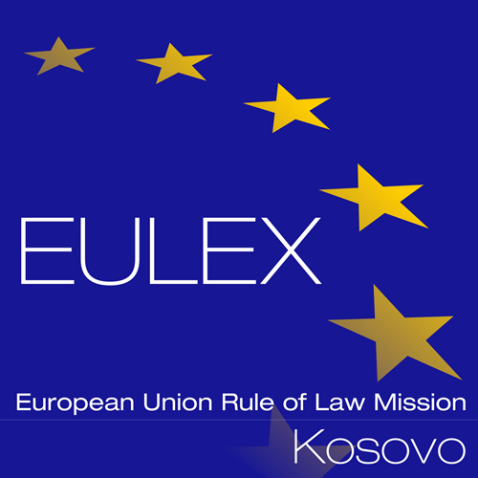
European Union Rule of Law Mission in Kosovo
EULEX Kosovo
Ndertesa Farmed
“Muharrem Fejza” p.n.
Lagja e Spitalit
10 000 Pristina, Kosovo
Tel: + (381) 38 78 2000
http://www.eulex-kosovo.eu

CLARIFICATIONS (1)

PUBLICATION REFERENCE: PROC/534/15/ Supply of Communications Equipment No.7 (EuropeAid/136883/ID/SUP/XK)

- Questions regarding Annex II+III Technical Specifications:

No | Question | Answer
1 | Lot 2 Item No. 1-3. There is requirement that carabiner should full fill CE 12275 requirement. Please confirm that carabiner, which confirm to EN 362 will be acceptable | Yes. Please refer to Corrigendum no. 1.
2 | Lot 2 item No. 1. Please confirm that carabiner with 10 Kn gate open will be accepted. | No, as stipulated in the Technical Specifications, a 15Kn gate open is required.
3 | Lot 2 Item No. 3. Please confirm that carabiner with 25Kn gate closed will be accepted | No, as stipulated in the Technical Specifications, a 36kN gate closed is required.
4 | Lot 2 Item No. 6. What does it mean “40Kn (20 Kn/20Kn)”? Breaking load, major axis? | 40kN Total Load 20Kn load each side of pully.
5 | Lot 2 Item. No 11. Please inform us what is length of lanyard? | Please refer to Corrigendum no. 1.
6 | Lot 2 Item No. 12. Please confirm that lanyard in 2 m length will be acceptable | Please refer to Corrigendum no. 1.
7 | Lot 2 Item No. 15. Please confirm that helmet, which full fill EN 397:2012 will be acceptable, because ANSI Z89.1, 1986 Type 2 Class C is American standard. | Please refer to Corrigendum no. 1.
8 | Lot 2 Item No. 17. What does it mean “ kit must be manufacturer sealed and ready to use”? Please let us know if kit with equipment, which full fill tender requirement, but assembled by tested specialists not in manufacturer’s place, will be accepted. All items will be high quality and harmonized for work as a kit. | The rescue must be pre-packed and sealed.  Please refer to Corrigendum no. 1.

