

European Union Rule of Law Mission in Kosovo
EULEX Kosovo
Ndertesa Farmed
“Muharrem Fejza” p.n.
Lagja e Spitalit
10000 Pristina, Kosovo
www.eulex-kosovo.eu

CORRIGENDUM NUMBER 1

TO THE TENDER DOSSIER

PUBLICATION REFERENCE: PROC/767/18/ Supply of Perimeter lights for EULEX compounds under Framework Contract no.2 (EuropeAid/139454/IH/SUP/XK)

The following corrections are made to the Tender Dossier

The following corrections are made to Annex II+ III Technical Specifications – line item no. 1:

The former text:

Item  Number | Specifications | Specifications Offered (incl. brand/model) | Notes, remarks, ref to documentation | Evaluation Committee’s notes
Supply of Energy Saving Aluminium 80-84W LED Street Lighting Fixtures for Outdoor, 5000-6500K, REX-R001

Qty: 45.00 EA

Shall read now:

Item  Number | Specifications | Specifications Offered (incl. brand/model) | Notes, remarks, ref to documentation | Evaluation Committee’s notes
Supply of Energy Saving Aluminium 80-84W LED Street Lighting Fixtures for Outdoor, 5000-6500K, REX-R001 or 100 watt Street Lighting Fixtures containing of 100 psc of 1W LED’s for Outdoor, 5000-6500K, REX-R001

Qty: 45.00 EA

The former text:

Detailed Product Description

Energy Saving Aluminium 80-84W LED Street Lighting Fixtures for Outdoor, 5000-6500K, REX-R001

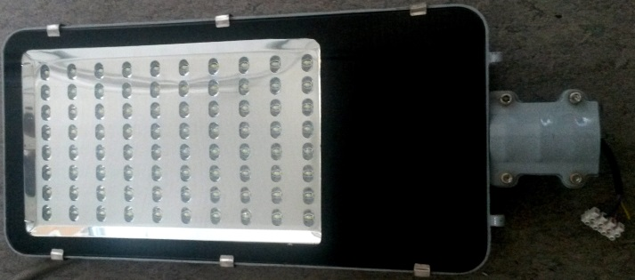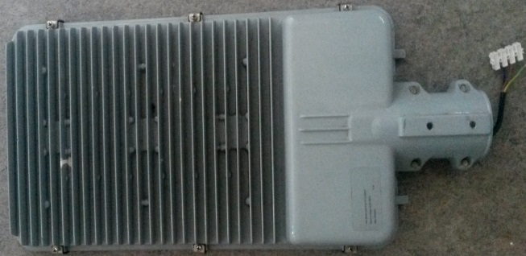

Technology parameter:
LED Quantity: | 84 pcs 1W LED
Input Voltage: | AC 170-250V 50/60Hz
Output Voltage: | DC 53V
Power Factor: | >0.95
Power Efficiency: | ≥90%
LED Luminous Efficiency: | >90Lm/W
Light output ratio: | >90%
Color Temperature: | 5000-6500K
Color Rendring Index: | >80
Junction Temperature: | <70℃
Working Environment: | Environment temperature -35~40℃, Relative humidity 10%~90%
Storage Temperature: | When it doesn't work, the storage temperature is -35 ~ 80 degrees
Protection Rating: | IP65
Lifespan: | 50000h
Body & Lampshade Material: | Aluminum Alloy + Toughened Glass + ABS
Net Weight: | 10.3 KG
Size: | L505 x W310 x H75mm

Shall read now:

Detailed Product Description

Energy Saving Aluminium 80-84W LED Street Lighting Fixtures for Outdoor, 5000-6500K, REX-R001 or 100 watt Street Lighting Fixtures containing of 100 psc of 1W LED’s for Outdoor, 5000-6500K, REX-R001

Technology parameter:
LED Quantity: | 84 pcs 1W LED
Input Voltage: | AC 170-250V 50/60Hz
Output Voltage: | DC 53V
Power Factor: | >0.95
Power Efficiency: | ≥90%
LED Luminous Efficiency: | >90Lm/W
Light output ratio: | >90%
Color Temperature: | 5000-6500K
Color Rendring Index: | >80
Junction Temperature: | <70℃
Working Environment: | Environment temperature -35~40℃, Relative humidity 10%~90%
Storage Temperature: | When it doesn't work, the storage temperature is -35 ~ 80 degrees
Protection Rating: | IP65
Lifespan: | 50000h
Body & Lampshade Material: | Aluminum Alloy + Toughened Glass + ABS
Net Weight: | 10.3 KG
Size: | L505 x W310 x H75mm

EoT

