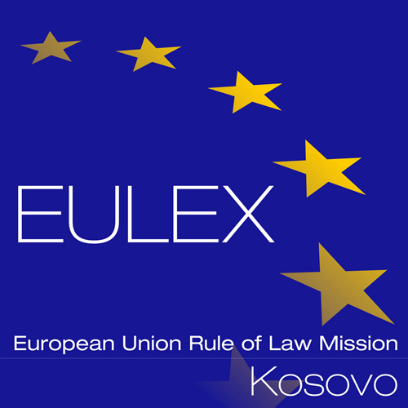

European Union Rule of Law Mission in Kosovo
EULEX Kosovo
Ndertesa Farmed
“Muharrem Fejza” p.n.
Lagja e Spitalit
10000 Pristina, Kosovo
Tel: +386 (0)43 78 2000
www.eulex-kosovo.eu

CORRIGENDUM NUMBER 1

PUBLICATION REFERENCE:
PROC/615/16 Supply of Metal and Steel Products under a Framework Contract No.5 (EuropeAid/137934/ID/SUP/XK)

This Corrigendum No. 1 is issue to reflect the following changes to the Tender Dossier:

1. PART B: DRAFT CONTRACT and SPECIAL CONDITIONS

SPECIAL CONDITIONS

Article 32 Warranty

The former text:

32.2 The commercial warranty as shown in the technical offer must be valid for 1 (one) year after provisional acceptance.

Shall be entirely deleted from the Tender Documents

32.2 The commercial warranty as shown in the technical offer must be valid for 1 (one) year after provisional acceptance.

2. ANNEX II-III TECHNICAL SPECIFICATIONS
MATRIX TECHNICAL DOCUMENTS
Annex II+III: Technical Specifications “Matrix Technical Documents”
The (x) marked documents must be added to the technical offer.
Line Item | Catalogue  for dimension | Manufacturers  Datasheets | Manufacturers Quality Control Certificate, ISO 9001 | Manufactures Warranty Declaration | Remarks
 | LOT 4 Metal
4-7 |  | X | X | min. 5 years rust resistance
11-15 |  | X | X | min. 5 years rust resistance
139-152 |  | X
158,159 |  | X |  | 2 years

Shall be replaced with the following table

Annex II+III: Technical Specifications “Matrix Technical Documents”
The (x) marked documents must be added to the technical offer.
Line Item | Catalogue  for dimension | Manufacturers  Datasheets | Manufacturers Quality Control Certificate, ISO 9001 | Manufactures Warranty Declaration | Remarks
 | LOT 4 Metal
9-17 |  | X | X | min. 5 years rust resistance
19-21 | X
111-120 |  | X
127-129 |  | X
138 |  | X |  | 2 years
211-216 |  | X | X

All other terms and conditions of the Tender Dossier remain unchanged. The above alteration and/or correction to the Tender Dossier is integral part of the Tender Dossier.

***

