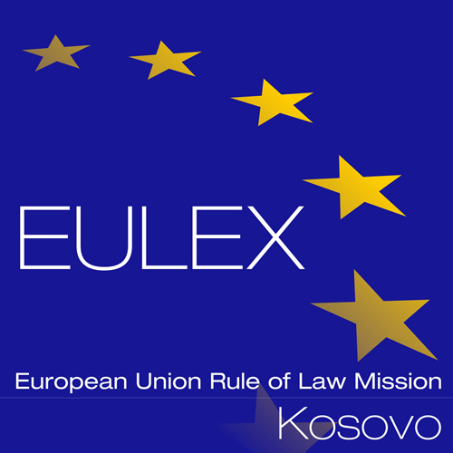
European Union Rule of Law Mission in Kosovo
EULEX Kosovo
Ndertesa Farmed
“Muharrem Fejza” p.n.
Lagja e Spitalit
10 000 Pristina, Kosovo
Tel: + (386) 43 78 2000
http://www.eulex-kosovo.eu

CORRIGENDUM NUMBER 1

TO THE CONTRACT NOTICE

PUBLICATION REFERENCE: PROC/587/15/ Spare Parts and Maintenance for Vehicles FWC no. 5 (EuropeAid/137575/IH/SUP/XK)

The following corrections are made to the Contract Notice

The former text:

16. Selection Criteria
2) Professional capacity of tenderer (based on i.a. items 4 and 5 of the Tender Form for a Supply Contract). The reference period which will be taken into account will be the last three years from submission deadline.
- The tenderer must be authorized( e.g. authorization letter) by to sell the spare parts as well as provide maintenance for the vehicles of the particular makes through official distribution chain appropriate for territory of Kosovo. The authorization must be certified (validated) by representative of , respectively:
- For Lot 1: Toyota Europe After Sales Department and Stoof International Aftersales Department( main office)
- For Lot 2: Volkswagen Group After Sales Department( main office)
- For Lot 3: Mercedes Benz After Sales Department( main Office),

as an instrument of verification that the authorizing letter has been issued by company , which is entitled to issue such a document.

Shall read now:

16. Selection Criteria
2) Professional capacity of tenderer (based on i.a. items 4 and 5 of the Tender Form for a Supply Contract). The reference period which will be taken into account will be the last three years from submission deadline.
- The tenderer must be authorized( e.g. authorization letter) by to sell the spare parts as well as provide maintenance for the vehicles of the particular makes through official distribution chain appropriate for territory of Kosovo. The authorization must be certified (validated) by representative of , respectively:
- For Lot 2: Volkswagen Group After Sales Department( main office)
- For Lot 3: Mercedes Benz After Sales Department( main Office),

as an instrument of verification that the authorizing letter has been issued by company , which is entitled to issue such a document.

For Lot 1: Toyota Europe After Sales Department and Stoof International Aftersales Department (main office) is no longer required.

All other terms and conditions of the Contract Notice remain unchanged.

