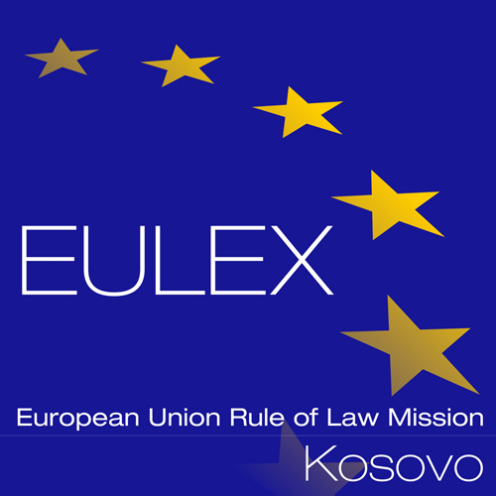

European Union Rule of Law Mission in Kosovo
EULEX Kosovo
Ndertesa Farmed
“Muharrem Fejza” p.n.
Lagja e Spitalit
10 000 Pristina, Kosovo
http://www.eulex-kosovo.eu

CLARIFICATIONS (1)

PUBLICATION REFERENCE: PROC/767/18/ Supply of Perimeter lights for EULEX compounds under Framework Contract no.2 (EuropeAid/139454/IH/SUP/XK)

Questions regarding Technical Specifications

No | Lot/  Item | Question | Answer
1 | Item no.1 | Supply of Energy Saving Aluminium 80-84W LED Street Lighting Fixtures for Outdoor, 5000-6500K, REX-R001  Question: Can we offer also 100W Led street light ? | Please refer to corrigendum no.1

