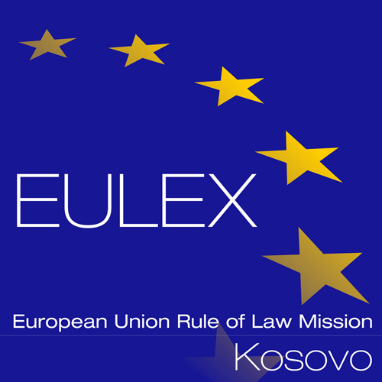

European Union Rule of Law Mission in Kosovo EULEX Kosovo
Ndertesa Farmed
“Muharrem Fejza” p.n.
Lagja e Spitalit
10 000 Pristina, Kosovo
http://www.eulex-kosovo.eu

CLARIFICATION (1)

PUBLICATION REFERENCE: PROC/589/15/ Renewal of Microsoft Assurance Licenses
(EuropeAid/137492/ID/SUP/XK)

Please see below clarification(s) to the queries raised by a potential tenderer regarding the subject procedure.

Regards.

No | Reference | Clarifications
1. | May you confirm that the After-Sales Service is not required for this tender? | Kindly be advised that the requirement is for the provision of renewal licenses only and does not require after-sales service.

.

