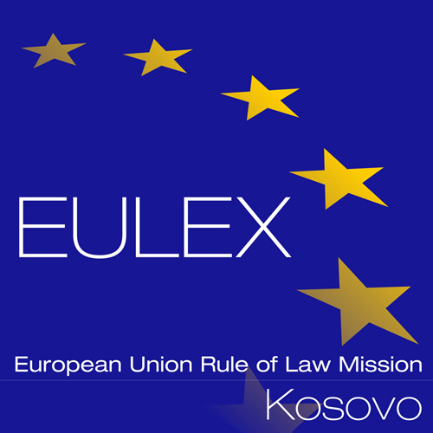

European Union Rule of Law Mission in Kosovo
EULEX Kosovo
Ndertesa Farmed
“Muharrem Fejza” p.n.
Lagja e Spitalit
10000 Pristina, Kosovo
www.eulex-kosovo.eu

CLARIFICATIONS No. 1

PUBLICATION REFERENCE: PROC/926/19/Supply of IT Equipment No.14
EuropeAid/140632/ID/SUP/XK

Question  No | Question | Answer
1 | Intelligence Module for APC Symmetra LX 16KVA Tower*  Qty:5 Intelligence Module with P/N: SYMIM5  As information from vendor these intelligence modules must be in pair as they must have same firmware and that can be done at vendors place.  How many APC Symmetra LX UPSs you have on location that spare parts are for? | Lot 1, Item 15: Please be informed that we have 6 pcs x APC Symmetra LX UPS’s in production and 6 pcs in Stock.
2 | What is the planed capacity for backup, as Veritas is licensing per TB? | Lot 4, Item 4: The Veritas backup licenses are not part of this project. We require compatibility with Veritas Backup Exec, as this is the currently in use backup solution of the contracting authority.
3 | LOT 4: STORAGES and DISK to DISK BACKUP SYSTEM, item no. 4- Disk to Disk Backup System, specification “Veritas Backup 16 or new compatible”.  Should these licenses be supplied, or they will be provided by Contracting Authority?  If they should be supplied, please provide more details about agents, options and subscription period in order to determine the right product. | Lot 4. Item 4: The Veritas backup licenses are not part of this project as the Contracting Authority has the licenses. We require compatibility with Veritas Backup Exec, as this is the currently in use backup solution of the contracting authority.

