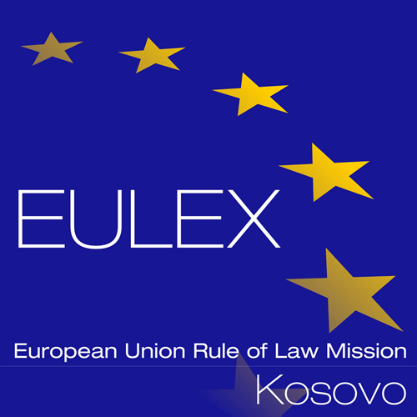

European Union Rule of Law Mission in Kosovo
EULEX Kosovo
Ndertesa Farmed
“Muharrem Fejza” p.n.
Lagja e Spitalit
10 000 Pristina, Kosovo
http://www.eulex-kosovo.eu

CLARIFICATIONS (1)

PUBLICATION REFERENCE: PROC/771/18/ Framework Contract for the Supply of Drinking Water No.7 (EuropeAid/139622/IH/SUP/XK)

Questions regarding Technical Specifications

No | Question | Answer
1 | The amount of tender guarantee that we have to supply together with the offer will be of  360,00 Euro like info on art.22/page 13/92 of 103476-20180406-Tender_Dossier_Drinking_Water_no.7.pdf  or  400,00 Euro like info on Part 3/page 7/92 of 103476-20180406-Tender_Dossier_Drinking_Water_no.7.pdf ? | Please refer to corrigendum no.1
2 | Is possible to supply the bid bond in cash deposit through your offices? | As stipulated under Article 22 of Instructions to Tenderers, The tender guarantee referred to in Article 11 above is set at 360.00 Euros (three hundred and sixty Euros) and must be presented in the form specified in the annex to the tender dossier. It must remain valid for 45 days beyond the period of validity of the tender. Tender guarantees provided by tenderers who have not been selected will be returned together with the information letter that the tenderer has been unsuccessful. The tender guarantee of the successful tenderer will be released on signing of the contract, once the performance guarantee has been submitted.
3 | Which bid bond we have to follow? TENDER GUARANTEE FORM on page 65/92 or PRE-FINANCING GUARANTEE FORM on page 66/92 of 103476-20180406-Tender_Dossier_Drinking_Water_no.7.pdf ? | Please be informed that at this stage of the tender procedure you will have to submit only the tender guarantee, using the tender guarantee form.
4 | Please clarify the difference between TENDER GUARANTEE FORM on page 65/92 and PRE-FINANCING GUARANTEE FORM on page 66/92 103476-20180406-Tender_Dossier_Drinking_Water_no.7.pdf ? | A tender guarantee assures the Contracting Authority that submitted tenders will not be withdrawn. Please refer to Answer no.2 for more details.  A pre-financing guarantee is requested only to the awarded tenderer, in case pre-financing payment is requested by the contractor. For more details, please refer to Article 26 of the Special Conditions and Article 26 of the General conditions.
5 | Regarding Part 3: Documentation of 103476-20180406-Tender_Dossier_Drinking_Water_no.7.pdf ?  where Tenderer must provide an official document; issued within 12 month from the date of submission of the tenderer’s offer; by the “National Institute of Public Health of Kosovo” or an equivalent public foreign institution certifying that the Water to be supplied meets the minimum basic standards laid down by the “ National Institute of Public Health of Kosovo”.  please clarify if the time for obtain the document from Kosovo authority and in case if is possible to supply it after closing bid deadline ? | Please be informed that at the stage of the tender submission you will have to have a valid official document issued by the National Institute of Public Health of Kosovo, which could have been issued at any time within 12 month from the date of submission of the tenderer’s offer.

