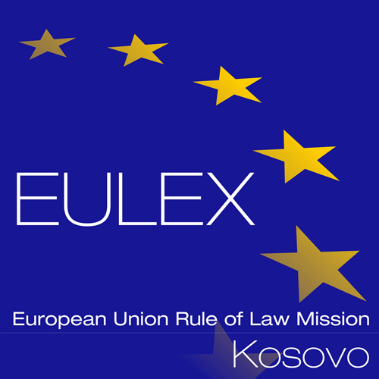

European Union Rule of Law Mission in Kosovo
EULEX Kosovo
Ndertesa Farmed
“Muharrem Fejza” p.n.
Lagja e Spitalit
10 000 Pristina, Kosovo
http://www.eulex-kosovo.eu

CLARIFICATIONS (1)

PUBLICATION REFERENCE: EuropeAid/140268/ID/SUP/XK (PROC/854/19) – IT Equipment No.13

Questions regarding Technical Specifications

No | Lot/  Item | Question | Answer
1 | Lot 3 | Most of the items requested under Lot 3 - SPARE PARTS SERVERS and STORAGES, which are replacement parts for your existing servers and storages, most of them very old, cannot be found in market as new.  Based on the information we got from different sources, they can be found only as“refurbished”.  Could you please confirm if refurbished parts can be offered for this Lot? | No, refurbished spare parts will not be accepted. In accordance with Article 32.1 of the draft contract of the tender dossier, the contractor shall warrant that the supplies are new, unused, of the most recent models and incorporate all recent improvements in design and materials, unless otherwise provided in the contract. The contractor shall further warrant that all supplies shall have no defect arising from design, materials or workmanship, except insofar as the design or materials are required by the specifications, or from any act or omission, that may develop under use of the supplies in the conditions obtaining in the country of the contracting authority.  Furthermore, we kindly ask you to refer to corrigendum number 1 which allows Tenderers to offer equivalent/compatible items for all items of Lot three (3) except for items 13, 14 and 34.
2 | Lot 5/Item1 | Can we offer 3U storage instead of 2U? | No, the offered storage solution should be according to technical specifications (i.e. annex II of the tender dossier) of Lot 5, Item 1.
3 | Lot 5 | Can we offer 3U storage with populated with NL-SAS drives instead of 10K SAS and use only one enclosure with 3U which will reduce the total rack space. Since you are not looking for performance with this storage as it is an entry level we believe that 10K SAS drives are not necessary. | No, the offered storage solution should be according to technical specifications (i.e. annex II of the tender dossier) of Lot 5.
4 | Lot 5 | Can we offer Commvault licenses instead of Veritas as it is equivalent or better than Veritas (it is considered top1 backup software)? | We do not require backup software license in Lot 5. The offered backup hardware solution should be compatible with Veritas Backup Exec since it is currently used by the Contracting Authority.
5 | Lot 5 | Can we offer backup appliance with 34TB usable instead of 36TB as the appliance we are considering has superior data reduction techniques which will make the total logical available capacity on the appliance larger than the one specified? | No, the offered backup appliance should be according to technical specification of Lot 5.
6 | Lot 5 | “Installation: vendor based initial installation and provisioning”  Can you please clarify this, does it means that the Certified Engineer from EO Economic Operator must do the installation, or the installation by the vendor. | The initial installation should be carried out by an engineer from the Economic Operator or the manufacturer/vendor of the equipment.
7 | Lot 4 | Which is the exact CPU that you require? Seems that you are asking for a CPU that is from the previous and not the last generation. | We don’t require a specific CPU. We require a processor with a minimum launch date 1st quarter of year 2016 and with min. 8 cores, min 2.10 GHz base frequency.
8 | Lot 4 | Can we offer a system that will satisfy the desired capacity requirement with less than 12 drives, but have the ability to extend in the future through expansion slot to 16 drive slots will that be acceptable? | No, the offered server appliance should be according to technical specifications (i.e. annex II of the tender dossier) of Lot 4.
9 | Lot 5 | Will you be using RAID 0 on your storage? Do you accept if we offer a storage that supports other (more advanced) RAID levels which provide advanced protection as RAID 0 provides no protection at all? The requested capacity of 80TB is usable or RAW capacity? Would you be reconsidering the usage of RAID 0 as it does not provide any protection at all and in case of failure all your data might be lost? How much support/warranty do you need, 1 or 3 years? | We requirement min. 80 TB usable storage (RAID0 equivalent) which means 80 TB raw capacity. RAID controller with minimum 12 GB/s SAS and minimum RAID Levels 0, 1, 5, 6.  We require three (3) years warranty as stipulated in the technical specifications (i.e. annex II of the tender dossier) for LOT 5, item 1.

