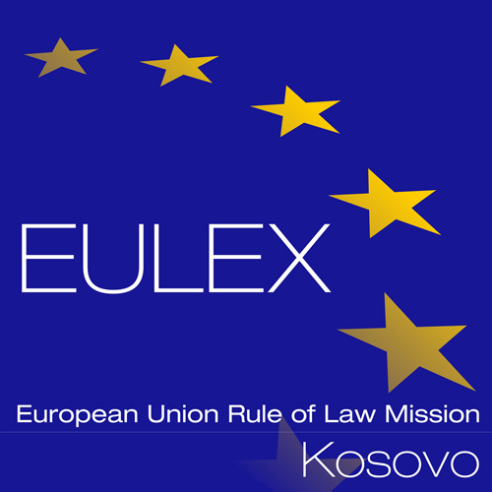

European Union Rule of Law Mission in Kosovo
EULEX Kosovo
Ndertesa Farmed
“Muharrem Fejza” p.n.
Lagja e Spitalit
10000 Pristina, Kosovo
www.eulex-kosovo.eu

CLARIFICATIONS No. 1

PUBLICATION REFERENCE: EuropeAid/139739/IH/SER/XK Vehicle Insurance Services No. 6 (PROC/794/18/)
Question  No | Question | Answer
1 | Since Kosovo based insurance companies are not eligible to provide Green Card Insurance we need to go in consortium with eligible companies which can provide this service. In order for them to qualify for participation in the tender, the respective National Bureau in order to provide authorization needs to have written consent by the Council of Bureaux.  After communicating with the National Motor Bureau of Macedonia, they informed us they still do not have a written consent to provide authorization to an insurance company eligible to provide green cards in Macedonia to offer this service in the Territory of Kosovo.  Please be so kind to advise us if this procedure with the Council of Bureuax has already been facilitated or not by EULEX Kosovo and instruct us accordingly. | As stipulated in point 21, Selection criteria, sub point 2 (b) of the contract notice, the candidate must be in possession of a valid authorization allowing issuance of green cards to EULEX, issued by the National Motor Insurers Bureau of which they are a member of.  Each National Motor Bureau assumes responsibility for arrangements with the Council of Bureuax. The Contracting Authority cannot intervene in such matters.

