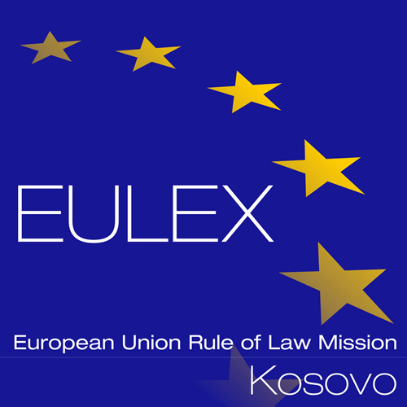

European Union Rule of Law Mission in Kosovo
EULEX Kosovo
Ndertesa Farmed
“Muharrem Fejza” p.n.
Lagja e Spitalit
10000 Pristina, Kosovo
www.eulex-kosovo.eu

CLARIFICATIONS No. 1

PUBLICATION REFERENCE: PROC/1160/22/Supply of Printing and Visibility material No. 5

Questions regarding the tender dossier

Question  No | Question | Answer
1 | After taking tender dossier, I would like to know what mandatory administrative documents are to submit during the biding process! Because of the complexity of this tender, I am not quite of this point, therefore I need these information. | In accordance with the provisions of Tender Dossier, Part A “Instructions to tenderers”, point 10.1 “Submission of tenders”, the tender “must include all the documents specified under point 11 of these Instructions”.  For your reference, please find below the above mentioned point 11 “Content of tenders”, listing all the documents that must be included in the tender.  - Content of tenders  Failure to fulfil the below requirements will constitute an irregularity and may result in rejection of the tender. All tenders submitted must comply with the requirements in the tender dossier and comprise:  Part 1: Technical offer:  a detailed description of the supplies tendered in conformity with the technical specifications, including any documentation required.  - Each tenderer is required to submit at no charge to the Contracting Authority a sample of the Items offered, except for items No. 16, 28, 29, 33, 55. Samples provided must be identical in quality to those that would be supplied under the contract – deviations in the dimension of samples are tolerated. Samples must be submitted in a sealed box indicating the items number, description and tenderer’s name. The unsuccessful tenderers may pick up the samples within 30 days from the notification of the contract award; samples not picked up will be discarded. The awarded tenderer will receive back the samples together with the provisional acceptance certificate.  - For items No. 16, 28, 29, 33, 55: Each tenderer is required to submit at no charge to the Contracting Authority at least one photo for each item as stipulated in the Technical Specifications, along with a description of the characteristics of the product as required in the technical specifications (Annex II+III). Photos (and/or catalogues) must be submitted in sealed envelopes indicating the item number.  The technical offer should be presented as per template (Annex II+III*, Contractor’s technical offer) adding separate sheets for details if necessary.  Part 2: Financial offer:  A financial offer calculated on a DAP basis for the supplies tendered.  This financial offer should be presented as per template (Annex IV*, Budget breakdown), adding separate sheets for details if necessary.  In case of doubt about the applicable VAT system, it is the tenderer's responsibility to contact his or her national authorities to clarify the way in which the European Union is exempt from VAT.  Part 3: Documentation:  To be supplied using the templates attached*:  - The original signed tender guarantee, for 1,200.00 Euro;  - The ‘Tender Form for a Supply Contract’, together with its Annex 1 'Declaration on honour on exclusion criteria and selection criteria', both duly completed, which includes the tenderer’s declaration, point 7, (from each member if a consortium and capacity-providing entities or subcontractors (if any)). Signed originals of the Declaration on honour shall be submitted.  - The details of the bank account into which payments should be made (financial identification form – document c4o1_fif_en) (Tenderers that have already signed another contract with the European Commission, may provide their financial identification form number instead of the financial identification form, or a copy of the financial identification form provided on that occasion, if no change has occurred in the meantime.)  - The legal entity file (document c4o2_lefind_en) and the supporting documents (Tenderers that have already signed another contract with the European Commission, may provide their legal entity number instead of the legal entity sheet and supporting documents, or a copy of the legal entity sheet provided on that occasion, if no change in legal status has occurred in the meantime).  To be supplied in free-text format:  - A description of the warranty conditions, which must be in accordance with the conditions laid down in Article 32 of the General Conditions.  - Duly authorised signature: an official document (statutes, power of attorney, notary statement, etc.) proving that the person who signs on behalf of the company/joint venture/consortium is duly authorised to do so.  - Documentary proof or statements required under the law of the country in which the company (or each of the companies for consortia) is established, to show that it is not in any of the exclusion situations listed in section 2.6.10.1. of the Practical Guide to contract procedures for EU external action. This evidence, documents or statements must be dated, no more than 1 year before the date of submission of the tender. In addition, a statement must be furnished stating that the situations described in these documents have not changed since then.  If the nature of your entity is such that it cannot fall into the exclusion situations and/or cannot provide the documents indicated above (for instance, national public administrations and international organisations), please provide a declaration explaining this situation.  The Contracting Authority may waive the obligation of any candidate or tenderer to submit the documentary evidence referred to above if such evidence has already been submitted for the purposes of another procurement procedure, provided that the issue date of the documents does not exceed one year and that they are still valid. In this case, the candidate or tenderer must declare on his/her honour that the documentary evidence has already been provided in a previous procurement procedure and confirm that his/her situation has not changed.  - Documentary evidence of the financial and economic capacity as well as the technical and professional capacity according to the selection criteria specified in the contract notice. (See further point 2.6.11 of the Practical Guide).  If the documentary evidence submitted is not written in one of the official languages of the European Union, a translation into the language of the procedure must be attached. Where the documents are in an official language of the European Union other than the one of the procedure, it is however strongly recommended to provide a translation into the language of the procedure, in order to facilitate the evaluation of the documents. Documentary proof or statements may be in original or copy. If copies are submitted, the originals must be available to send to the Contracting Authority upon request.  Remarks:  Tenderers are requested to follow this order of presentation.  Annex* refers to templates attached to the tender dossier. These templates are also available on: https://wikis.ec.europa.eu/display/ExactExternalWiki/ePRAG

DAP (Delivered At Place) — Incoterms 2020 International Chamber of Commerce http://www.iccwbo.org/incoterms/.

