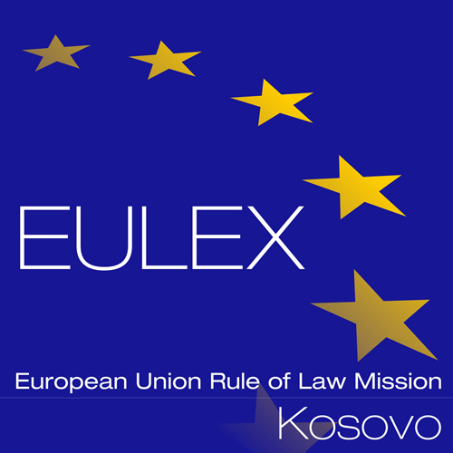

European Union Rule of Law Mission in Kosovo
EULEX Kosovo
Lidhja e Pejës, Industrial Zone P.O. Box 268
10000 Pristina, Kosovo
www.eulex-kosovo.eu

CLARIFICATIONS No. 1

PUBLICATION REFERENCE: PROC/1373/25/Framework Contract for the Supply of Automotive Spare Parts No.10

Questions regarding the tender dossier (Annex II +III: technical specifications + technical offer)

Question  No | Question | Answer
1 | “Type: COVER CLUTH (30210-JS10C)  (Must be OEM)  Qty:10  “Type: DISC CLUTH (30100-JS10B)  (Must be OEM)  Qty:10  Type:FLYWHEEL (12310-EB30A)  (Must be OEM)  Qty:10  The description consists of 3 codes while the part of the order comes complete with cover and clutch and bearing flywheel together, we as an economic operator ask you to make 1 combined item according to the manufacturer, this means that the parts must be replaced as a whole set, because if they are replaced as a whole set, because if they are replaced 1 by 1, the machine will constantly have defects. | Please adhere to the listed items indicated in Annex II +III: technical specifications + technical offer of the tender dossier as all of them are available on the market.
2 | “Type: DISC CLUTCH (30100-5X00B)  (Must be OEM)  Qty:10  “Type: COVER CLUTCH (30210-5X00A)  (Must be OEM)  Qty:10  The description consists of 2 codes while the part of the order comes complete with cover and clutch and bearing together, we as an economic operator ask you to make 1 combined item according to the manufacturer, this means that the parts must be replaced as a whole set, because if they are replaced as a whole set, because if they are replaced 1 by 1, the machine will constantly have defects. | Please adhere to the listed items indicated in Annex II +III: technical specifications + technical offer of the tender dossier as all of them are available on the market.

EoT

