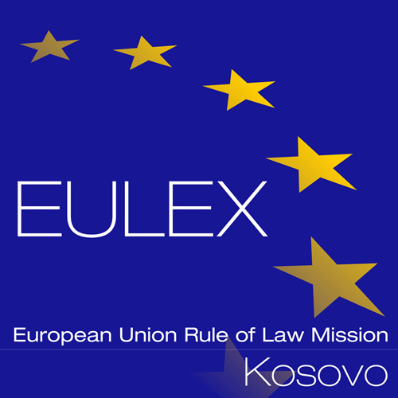

European Union Rule of Law Mission in Kosovo
EULEX Kosovo
Ndertesa Farmed
“Muharrem Fejza” p.n.
Lagja e Spitalit
10000 Pristina, Kosovo
www.eulex-kosovo.eu

CORRIGENDUM NUMBER 1

TO THE TENDER DOSSIER

PUBLICATION REFERENCE: PROC/771/18/ Framework Contract for the Supply of Drinking Water No.7 (EuropeAid/139622/IH/SUP/XK)
The following corrections are made to the Tender Dossier

The following corrections are made to Article 11 to Instructions to Tenderers:

The former text:

Content of tenders
Part 3: Documentation:
To be supplied using the templates attached*:
- The tender guarantee, for 400.00 (four hundred) Euros;

Shall read now:

Content of tenders
Part 3: Documentation:
To be supplied using the templates attached*:
- The tender guarantee, for 360.00 (three hundred and sixty) Euros;

EoT

