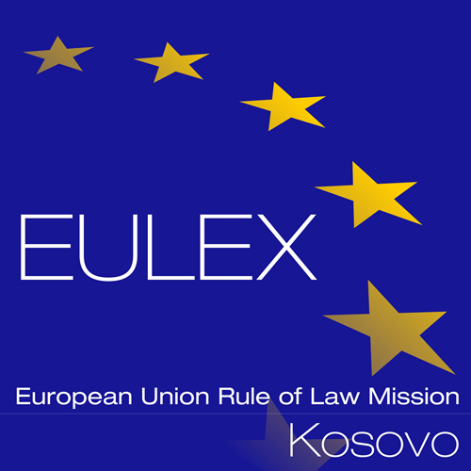

European Union Rule of Law Mission in Kosovo
EULEX Kosovo
Ndertesa Farmed
“Muharrem Fejza” p.n.
Lagja e Spitalit
10000 Pristina, Kosovo
www.eulex-kosovo.eu

CLARIFICATIONS No. 1

PUBLICATION REFERENCE: PROC/859/19/Supply of furniture and bed linen (EuropeAid/140276/IH/SUP/XK)

Question  No | Question | Answer
1 | Single Bed frame for the mattress size of W90 x L200. Steel bed frame with Epoxy/polyester powder | In reference to Lot one (1), furniture, please note that items number one (single bed frame for the mattress) and three (wardrobe, chipboard made) may be delivered as flat packs and assembled by the Contractor on-site or OR delivered ready-made i.e. already assembled.

