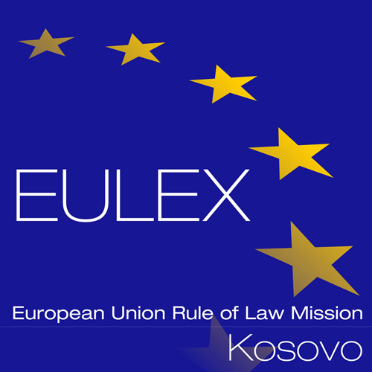

European Union Rule of Law Mission in Kosovo
EULEX Kosovo
Ndertesa Farmed
“Muharrem Fejza” p.n.
Lagja e Spitalit
10 000 Pristina, Kosovo
http://www.eulex-kosovo.eu

CLARIFICATIONS (2)

PUBLICATION REFERENCE: PROC/1056/21/Reorganisation of ECM Mitrovica

Question regarding Bill of Quantities

No | Question | Answer
1. | We were interested to know if the Consolidated Bill of Quantities must be filled with prices that include VAT and other taxes as per the regulation in Kosovo (18%); or should the listed prices in the BoQ be excluded from taxes. In the tender dossier Article 48 stipulates that the tenderer must account for relevant tax arrangements. Could you please let us know if the final BoQ must account for the relevant taxes in the unit prices and the final price that we submit for this tender procedure?  If that is not the case, will the EULEX Kosovo provide reimbursements for the relevant taxes according to the Kosovo legislation. | Please note that Article 4 of the draft contract agreement stipulates the following: The Contracting Authority hereby agrees to pay the Contractor in consideration of the execution and completion of the works and remedying of defects therein the amount of:  - Contract price (excluding VAT/other taxes) euro  - Contract price (in words: euro )  or such other sum as may become payable under the provisions of the Contract at the times and in the manner prescribed by the Contract. VAT will be paid in compliance with the binding regulations, national law and international agreements concerning the execution of the project. VAT and other taxes shall not be paid on the funds originating from EU funds.  Additionally, kindly be informed that: EULEX Kosovo is a diplomatic mission and according to UNMIK Executive Decision No 2008/36 of 9 December 2008, it is granted exemption from all customs duties, taxes, and related charges other than charges for storage, cartage and similar services, on articles for its official use.  EULEX Kosovo, does not provide reimbursement for any kind of taxes. It is the responsibility of the contractor to contact the relevant authorities for such matters. However, if and whenever possible, EULEX may offer assistance for customs clearance matters.

