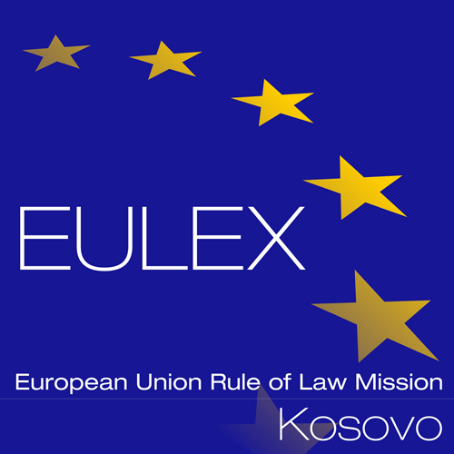

European Union Rule of Law Mission in Kosovo
EULEX Kosovo
Ndertesa Farmed
“Muharrem Fejza” p.n.
Lagja e Spitalit
10000 Pristina, Kosovo
www.eulex-kosovo.eu

CORRIGENDUM NO.2

PUBLICATION REFERENCE: EuropeAid/139739/IH/SER/XK Vehicle Insurance Services No. 6 (PROC/794/18/)

1) The following changes are made to the Contract Notice

The former text:

23. Deadline for receipt of applications
On 25 September 2018 at 15:00hrs (Kosovo time zone).
Any application received after this deadline will not be considered.

Shall read now:

23. Deadline for receipt of applications
On 10 October 2018 at 15:00hrs (Kosovo time zone).
Any application received after this deadline will not be considered.

Other terms and conditions of the Contract Notice remain the same.

EoT

