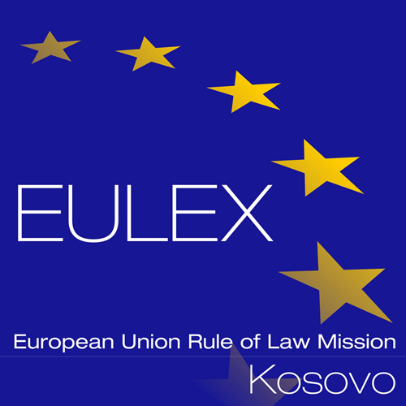

European Union Rule of Law Mission in Kosovo
EULEX Kosovo
Ndertesa Farmed
“Muharrem Fejza” p.n.
Lagja e Spitalit
10000 Pristina, Kosovo
www.eulex-kosovo.eu

CLARIFICATIONS No. 1

PUBLICATION REFERENCE: PROC/956/20/ Spare Parts and Maintenance for Vehicles - Volkswagen group FWC No.4 (EuropeAid/140483/DD/SUP/XK)

- Questions regarding the tender dossier

Question  No | Question | Answer
1 | We are Turkish company locating in Turkey. Is there any obligation for us to submit the tender? | As stipulated under Article 8 of the Contract Notice, Eligibility and rules of origin: …The participation of natural and legal persons in the award of procurement contracts financed out of the Mission's budget is open without limitations.
2 | We will submit the tender by email. Should we still send the “Tender Guarantee” by cargo or only the soft copy from e-mail is enough? | Please note that if you decide to submit the tender electronically, then the tender guarantee is also accepted in a soft copy.

