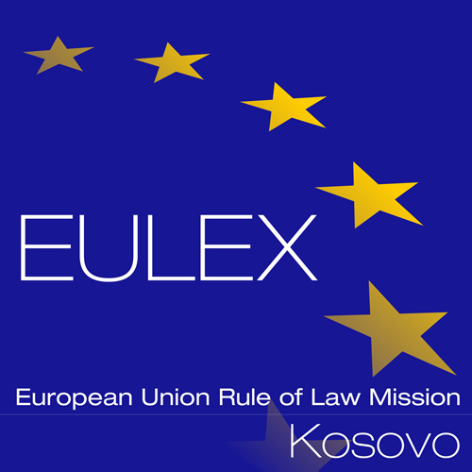

European Union Rule of Law Mission in Kosovo
EULEX Kosovo
Ndertesa Farmed
“Muharrem Fejza” p.n.
Lagja e Spitalit
10 000 Pristina, Kosovo
http://www.eulex-kosovo.eu

CLARIFICATIONS (3)

PUBLICATION REFERENCE: PROC/444/13/Ammunition and Job Specific Items (EuropeAid/135132/M/SUP/XK)

Questions regarding Technical Specifications

No | Lot/  Item | Question | Answer
1 | Lot1/ Item 45 | Item 45. of the LOT 1 (Armorer's hammers set, Qty:1, Set of three hammers: 100, 200 and 300 grams weight.) is lacking information about:  a) the material, which the hammers are made of (brass, nylon, plastic, or otherwise);  b) diameter of the head  c) length of the handle | - Please refer to corrigendum no. 2  - There are no specific requirements for the diameter of the head. However, Tenderers are reminded to heed the weight requirements stipulated in the Technical Specifications.  - Please refer to corrigendum no. 2

