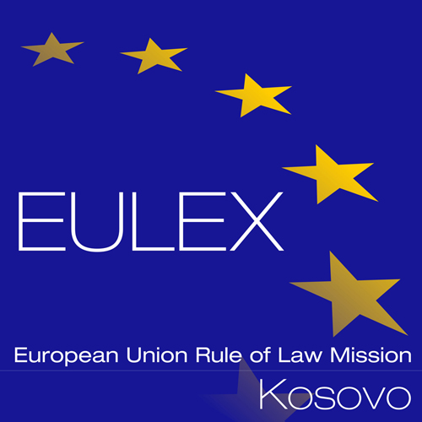

Pristina, 26 October 2021

Subject: Minutes of the Mandatory Site Visit in ECM Mitrovica
Ref: PROC/1056/21/Reorganisation of ECM Mitrovica
The mandatory site visit related to the tender for the Reorganisation of ECM Mitrovica – Str. Ferki Lisica, 40000 Mitrovica, Kosovo took place as follows:
Mandatory site was and clarification meeting held by the Contracting Authority on 26th of October 2021, at 11:00 hrs, EULEX Mitrovica Center Str. Ferki Lisica n.n, 40000 Mitrovica, Kosovo.

A. Overview of the Meeting in Mitrovica.

Representatives of eight (08) companies attended the site visit i.e Limit Project, Uniproject, Arking, Construction Group, Arc Project, Stenton Gradba doo,
BM Group and Protech.
EULEX Procurement Section opened the meeting and reminded the attendees about procedural rules and the deadline for request for any clarification from the Contracting Authority (i.e. 17th of November 2021 at 17:00hrs). The Contracting Authority will reply to all clarification requests by 26th of November 2021.
Attendees were strongly advised to respect the submission deadline; no offer will be accepted and examined if received after the set deadline (i.e. 08th of December 2021 at 15:00 hrs). Given the specific circumstances, the tender opening session may be organized by video conference on 08th of December 2021 at 15:30 hrs. However, the tenderers are requested to inform the Contracting Authority in advance if they wish to attend the public opening meeting. The attendees were also informed of the possibility of requesting the tender opening report by sending an email to tenders@eulex-kosovo.eu. Additionally, the tender guarantee should be submitted in the format presented in the Tender Dossier, in English Language and in original. Moreover, exceptionally, the offers may be submitted electronically, via email at tenders@eulex-kosovo.eu. The attendees were strongly advised to check often the EULEX website for tenders (Tenders - EULEX - European Union Rule of Law Mission in Kosovo (eulex-kosovo.eu), in order to informed about any additional information/clarification/corrigendum related to this project.

B. Technical Information.

EULEX Building Management have briefed companies present on the technical requirements for the Project. All the companies were showed the locations that are included in this project. Companies were briefed on the future requirements in the Compound. General overview of the Bill of Quantities for each individual building were shown to the companies and the companies made themselves familiar for the requirements in order to submit their offers.
All were given the possibility to enter the building premises, walk around the Compound where the works are to take place.
After visiting the site and having a better overview, companies have been reminded that if any other technical clarification is required a request for clarification should be submitted in writing within the set deadline.
In accordance with article 6.2 of the Instructions to Tenderers a certificate of attendance was issued to each attendee. In line with clause 12.1.12 of the Instructions to Tenderers, attendees were reminded to include the certificate of their site visit in their tender.
The site visit was completed at 13:00 hrs.

End of Text.

